PREDICTIVE ANALYTICS AND PERSONALIZED RECOMMENDATIONS FOR ENHANCED USER EXPERIENCE IN E-COMMERCE
A PROJECT REPORT
(NEXT BASKET)
Submitted By
Satheesh Kumar K
in partial fulfillment for the award of the degree of
BACHELOR OF TECHNOLOGY
In
INFORMATION TECHNOLOGY
HINDUSTHAN INSTITUTE OF TECHNOLOGY, COIMBATORE
ANNA UNIVERSITY: CHENNAI 600 025
[MONTH YEAR]

BONAFIDE CERTIFICATE
Certified that this main project report "Predictive Analytics and Personalized Recommendations for Enhanced User Experience in E-Commerce (Next Basket)" is the bonafide work of "Satheesh Kumar K" who carried out the project work under my supervision.
SIGNATURE  Dr.M.Duraipandian, M.E,Ph.D.,  SUPERVISOR  Information Technology  Hindusthan Institute of Technology  Coimbatore - 641032 | SIGNATURE  Dr.M.Duraipandian, M.E,Ph.D.,  HEAD OF THE DEPARTMENT  Information Technology  Hindusthan Institute of Technology  Coimbatore - 641032

Submitted for the University Project Viva Voice Examination Conducted on ........................
INTERNAL EXAMINER EXTERNAL EXAMINER

ACKNOWLEDGEMENT
I express my sincere thanks to Hindusthan Educational and Charitable Trust for providing me the necessary facilities to bring out the project successfully. I feel grateful to record my thanks to the Managing Trustee Tmt.Saraswathi Khannaiyann for all the s upport and the ray of strengthening hope extended to my project. It is a moment of immense pride for me to reveal profound thanks to our respected Principal, Dr.C.Natarajan, M.E.,Ph.D., who happens to be the striving force in all my endeavours.
I take immense pleasure in conveying my hearty thanks to Dr.M.Duraipandian, M.E.,Ph.D., Professor and Head of Information Technology Department for providing an opportunity to work on this project. His valuable suggestions helped me a lot to do this project
successfully. A word of thanks would not be sufficient for the work of my project guide Dr.M.Duraipandian, M.E.,Ph.D., Professor and Head of Information Technology Department who leads me through every trying circumstance. I deeply express my gratitude to all the Faculty Members and Support staff of the Department of Information Technology, for their
Satheesh Kumar K

ABSTRACT
E-commerce is a business model that enables the buying and selling of goods and services over the internet. In a competitive digital market where customer preferences change quickly, sellers struggle to predict demand and avoid stock shortages or overstocking, while buyers expect personalized and relevant product recommendations. Existing e-commerce systems often rely on manual monitoring, generic recommendations and limited automated alerts.
Next Basket is an integrated e-commerce platform that addresses these problems through predictive analytics and a recommendation engine. The predictive component uses an ARIMA (AutoRegressive Integrated Moving Average) model, trained on historical order data, to forecast 30-day product demand and alert sellers about potential stock shortages. The recommendation engine uses a Decision Tree classifier, built on per-category purchase history and the current cart, to predict the next category a customer is likely to buy from and to suggest top-rated in-stock products from it as the "next basket".
The system is developed as a web application. The front end is a React 18 single-page application built with Vite, Tailwind CSS and Recharts. The back end is a FastAPI (Python) service that uses Motor for asynchronous access to MongoDB and JWT-based, role-aware authentication. pandas, NumPy, statsmodels and scikit-learn support the data analysis and machine learning tasks. Separate dashboards are provided for the administrator, sellers and customers, together with sales forecasting, next-basket recommendation, live model-training progress and in-app stock alerts. The report presents the literature survey, system analysis, design, methodology, implementation, testing and results.

TABLE OF CONTENTS
Right-click and choose "Update Field" to build the table of contents.

LIST OF FIGURES
Figure 1: System Architecture
Figure 2: Level 0 Data Flow Diagram
Figure 3: Level 1 Data Flow Diagram
Figure 4: Level 2 Data Flow Diagram (Forecast and Recommend)
Figure 5: Admin Login
Figure 6: Training Phase
Figure 7: Forecaster Model: Data Collection (ARIMA stage 1)
Figure 8: Forecaster Model: Pre-processing (ARIMA stage 2)
Figure 9: Forecaster Model: Build and Train (ARIMA stage 3)
Figure 10: Forecaster Model: Forecast (ARIMA stage 4)
Figure 11: Seller Login
Figure 12: Add Product
Figure 13: Customer Registration
Figure 14: Customer Login
Figure 15: Products
Figure 16: Cart and Next Basket Recommendation
Figure 17: Purchased Orders
Figure 18: Sales Forecasting

LIST OF TABLES
Table 1: Software stack used
Table 2: Roles and capabilities
Table 3: Functional test cases
Table 4: API endpoints
Table 5: Structure of the users collection (admin, sellers, customers)
Table 6: Structure of the categories collection
Table 7: Structure of the products collection
Table 8: Structure of the cart collection
Table 9: Structure of the orders collection
Table 10: Structure of the reviews collection
Table 11: Structure of the user_purchases collection (recommendation features)
Table 12: Structure of the user_searches collection

LIST OF ABBREVIATIONS
AI - Artificial Intelligence
API - Application Programming Interface
ARIMA - AutoRegressive Integrated Moving Average
CSS - Cascading Style Sheets
CSV - Comma-Separated Values
GUI - Graphical User Interface
HTML - HyperText Markup Language
JWT - JSON Web Token
JSON - JavaScript Object Notation
ML - Machine Learning
REST - Representational State Transfer
SPA - Single-Page Application
SSE - Server-Sent Events
ADF - Augmented Dickey-Fuller

1. INTRODUCTION

1.1. OVERVIEW
Ecommerce = electronic commerce. In simple terms, it means running an online business. It refers to the selling and purchasing of goods and services over the internet where the exchange of money and data takes place via protected connections in order to ex ecute a transaction. Ecommerce offers a number of benefits over “brick and mortar” stores. It allows customers to easily find their desired product(s) through a large database. They can research the product beforehand, compare prices, learn more from customer reviews, and then buy it once their concerns are rectified by the online customer support representative.
E-commerce has been around since the early 1990s when Amazon just sold books.
Today, it’s a multibillion-dollar industry. According to Statista, the U.S. e-commerce industry is expected to eclipse $1 trillion in value in 2024, making it a major economic st aple for the national economy. E-commerce is an easy -to-launch and suitable -for-most business idea, which has gained the attention of entrepreneurs of all ages in the country. From local shop owners to huge organizations, everyone is looking to create a presence in the online business world. The future of e-commerce can be considered to be bright, and the best time to enter the domain is now. E-commerce works in the same way as any physical store. The only difference is that e-commerce is powered by the internet and is also not limited to any geographical area or region.

1.1.1. Types of E-commerce
Depending on the goods, services, and organization of an ecommerce company, the business can opt to operate several different ways. Here are several of the popular business models.
- Business-to-Consumer (B2C)
B2C e -commerce companies sell directly to the product end -user. Instead of distributing goods to an intermediary, a B2C company performs transactions with the consumer that will ultimately use the good. This type of business model may be used to sell products (like your local sporting goods store's website) or services (such as a lawn care mobile app to reserve landscaping services). This is the most common business model and is likely the concept most people think about when they hear the term e-commerce.
- Business-to-Business (B2B)
Similar to B2C, an e -commerce business can directly sell goods to a user. However, instead of being a consumer, that user may be another company. B2B transactions often entail larger quantities, greater specifications, and longer lead times. The company placing the order may also have a need to set recurring goods if the purchase is for recurring manufacturing processes.
- Business-to-Government (B2G)
Some entities specialize as government contractors providing goods or services to agencies or administrations. Similar to a B2B relationship, the business produces items of value and remits those items to an entity. B2G e-commerce companies must often meet government requests for proposal requirements, solicit bids for projects, and meet very specific product or service criteria. In addition, there may be joint government endeavors to solicit a single contract through a government-wide acquisition contract.
- Consumer-to-Consumer (C2C)
Established companies are the only entities that can sell things. E-commerce platforms such as digital marketplaces connect consumers with other consumers who can list their own products and execute their own sales. These C2C platforms may be auction -style listings (i.e. eBay auctions) or may warrant further discussion regarding the item or service being provided (i.e. Craigslist postings). Enabled by technology, C2C e -commerce platforms empower consumers to both buy and sell without the need for companies.
- Consumer-to-Business (C2B)
Modern platforms have allowed consumers to more easily engage with companies and offer their services, especially related to short-term contracts, gigs, or freelance opportunities. For example, consider listings on Upwork. A consumer may solicit bids or interact with companies that need particular jobs done. In this way, the e -commerce platform connects businesses with freelancers to enable consumers greater power to achieve pricing, scheduling, and employment demands.
- Consumer-to-Government (C2G)
Less of a traditional e -commerce relationship, consumers can interact with administrations, agencies, or governments through C2G partnerships. These partnerships are often not in the exchange of service but rather, the transaction of obligation. For example, uploading your federal tax return to the Internal Revenue Service (IRS) digital website is an e- commerce transaction regarding an exchange of information. Alternatively, you may pay your tuition to your university online or remit property tax assessments to your county assessor.

1.2. PROBLEM STATEMENT
E-commerce businesses face significant challenges in managing their stock effectively, primarily stemming from difficulties in accurately predicting demand and inefficient inventory
management processes. The task of forecasting demand is complex, influenced by factors such as seasonality, shifting consumer trends, and external market dynamics. Inaccurate predictions often lead to stockouts, where popular items become unavailable, resu lting in lost sales opportunities and disgruntled customers. Conversely, overestimating demand leads to overstocking, tying up capital in excess inventory and increasing storage costs. Additionally, outdated inventory management processes contribute to inefficiencies in tracking stock levels, replenishing inventory, and managing stock across multiple channels or warehouses. Manual or outdated systems lack real -time visibility into inventory movements, hindering decision - making and resulting in suboptimal in ventory allocation and fulfillment processes. These inefficiencies drive up operational costs, including storage expenses and labor costs, while also increasing the risk of inventory obsolescence.
Furthermore, e -commerce platforms often struggle with personalization limitations, depriving users of a tailored shopping experience. Without personalized product recommendations, platforms deliver generic shopping experiences where users are presented with a broad range of products that may not align with their preferences or interests. This generic approach undermines engagement, reduces conversion rates, and can lead to missed revenue opportunities. Moreover, failure to tailor recommendations based on in dividual preferences and past purchase behavior diminishes customer satisfaction and loyalty. In today's competitive landscape, customers expect personalized experiences that cater to their unique preferences and needs. The absence of personalized recommen dations also hinders cross - selling and up -selling opportunities, as platforms miss chances to suggest complementary or higher-value products based on customers' purchase histories or browsing behaviors. To address these challenges, e -commerce businesses mu st invest in advanced analytics and machine learning algorithms to improve demand forecasting accuracy and deliver personalized product recommendations. By leveraging data -driven insights and automation technologies, businesses can optimize their inventory management processes and enhance the overall shopping experience for customers.

1.3. ARTIFICIAL INTELLIGENCE
An AI is a computer system that is able to perform tasks that ordinarily require human intelligence. These artificial intelligence systems are powered by machine learning. Many of them are powered by machine learning, some of them are powered by specifical ly deep learning, some of them are powered by very boring things like just rules. Artificial intelligence
systems are critical for companies that wish to extract value from data by automating and optimizing processes or producing actionable insights. Artificial intelligence systems powered by machine learning enable companies to leverage large amounts of available data to uncover insights and patterns that would be impossible for any one person to identify, enabling them to deliver more targeted, personalized communications, predict critical care events, identify likely fraudulent transactions, and more.
Artificial intelligence systems work by using any number of AI techniques.
Machine Learning A machine learning (ML) algorithm is fed data by a computer and uses statistical techniques to help it “learn” how to get progressively better at a task, without necessarily having been programmed for that certain task. It uses historical data as input to predict new output values. Machine learning consists of both supervised learning (where the expected output for the input is known thanks to labeled data sets) and unsupervised learning (where the expected outputs are unknown due to the use of unlabeled data sets).
Deep Learning Deep learning is a type of machine learning that runs inputs through a biologically inspired neural network architecture. The neural networks contain a number of hidden layers through which the data is processed, allowing the machine to go “deep” in its learning, making connections and weighting input for the best results.
The Future Impact of Artificial Intelligence on the Global Supply Chain The global supply chain is a complex network of interconnected processes that enable the efficient flow of goods and services around the world. As technology continues to advance at an unprecedented pace, one innovation stands out as a game-changer: Artificial Intelligence (AI). AI has the potential to revolutionize the global supply chain, enhancing efficiency, optimizing decision -making, and driving significant cost savings. In this article, we will explore the transformative power of AI and how it will r eshape the global supply chain in the future.
- Enhanced Demand Forecasting
Accurate demand forecasting is crucial for supply chain management. AI algorithms can analyze vast amounts of historical and real -time data, considering various factors such as customer behavior, market trends, and even external factors like weather patter ns. By leveraging this data, AI -powered systems can provide more accurate demand forecasts, enabling companies to optimize inventory levels, reduce stockouts, and improve overall supply chain responsiveness.
- Intelligent Inventory Management
Optimizing inventory management is a perennial challenge for supply chain professionals. AI can provide real -time insights into inventory levels, consumption patterns, and lead times, enabling businesses to achieve leaner operations and reduce costs. By employing machine learning algorithms, AI systems can predict optimal inventory levels, minimize excess inventory, and even automate replenishment processes. Such intelligence - driven inventory management will foster better demand fulfillment, reduce waste, and improve cash flow.
- Smart Warehousing and Robotics
AI-driven technologies are transforming the warehousing landscape. Intelligent robots equipped with computer vision and machine learning capabilities can enhance warehouse operations, automating tasks such as sorting, picking, and packing. These robots can work alongside human employees, increasing efficiency and reducing errors. AI-powered warehouse management systems can optimize layout, streamline routing, and improve resource allocation, resulting in faster order fulfillment and increased customer satisfaction.
- Predictive Maintenance
Equipment breakdowns and maintenance issues can disrupt the supply chain and cause significant financial losses. AI can mitigate such risks by implementing predictive maintenance strategies. By analyzing real -time sensor data, AI algorithms can identify pa tterns, detect anomalies, and predict equipment failures before they occur. This proactive approach allows companies to schedule maintenance activities, minimize downtime, and reduce unplanned repairs, resulting in improved operational efficiency and cost savings.
- Supply Chain Visibility and Traceability
Global supply chains often suffer from a lack of visibility and transparency. AI - powered systems can overcome this challenge by enabling real -time tracking and traceability across the supply chain. By leveraging technologies such as Internet of Things (IoT ) devices, RFID tags, and blockchain, AI can provide end -to-end visibility, from raw material sourcing to final product delivery. This increased transparency enhances accountability, reduces counterfeit risks, and ensures compliance with regulatory standards.
- Optimized Route Planning and Logistics
AI algorithms can optimize route planning and logistics operations, considering various factors such as traffic conditions, fuel costs, and delivery time windows. By leveraging historical and real-time data, AI can identify the most efficient routes, recom mend alternative transportation modes, and even optimize vehicle loading. These intelligent logistics systems can reduce transportation costs, minimize carbon emissions, and enhance overall supply chain agility.
- Supplier Relationship Management
Maintaining strong relationships with suppliers is crucial for a resilient supply chain. AI can facilitate supplier relationship management by automating routine communication, streamlining order processing, and even predicting supplier performance. By ana lyzing supplier data and external market factors, AI-powered systems can identify potential risks and opportunities, allowing businesses to make informed decisions and build robust supplier networks.

1.3.1. DECISION TREE
A decision tree is a map of the possible outcomes of a series of related choices. It allows an individual or organization to weigh possible actions against one another based on their costs,
probabilities, and benefits. As the name goes, it uses a tree -like model of decisions. They can be used either to drive informal discussion or to map out an algorithm that predicts the best choice mathematically. A decision tree typically starts with a single node, which branches into possible outcomes. Each of those outcomes leads to additional nodes, which branch off into other possibilities. This gives it a tree-like shape.
There are three different types of nodes: chance nodes, decision nodes, and end nodes. A chance node, represented by a circle, shows the probabilities of certain results. A decision node, represented by a square, shows a decision to be made, and an end nod e shows the final outcome of a decision path. Decision tree learning employs a divide and conquer strategy by conducting a greedy search to identify the optimal split points within a tree. This process of splitting is then repeated in a top -down, recursive manner until all, or the majority of records have been classified under specific class labels. Whether or not all data points are classified as homogenous sets is largely dependent on the complexity of the decision tree. Smaller trees are more easily able to attain pure leaf nodes—i.e. data points in a single class. However, as a tree grows in size, it becomes increasingly difficult to maintain this purity, and it usually results in too little data falling within a given subtree. When this occurs, it is known as data fragmentation, and it can often le ad to overfitting. As a result, decision trees have preference for small trees, which is consistent with the principle of parsimony in Occam’s Razor; that is, “entities should not be multiplied beyond necessity.” Said differently, decision trees should add complexity only if necessary, as the simplest explanation is often the best. To reduce complexity and pr event overfitting, pruning is usually employed; this is a process, which removes branches that split on features with low importance. The model’s fit can then be
evaluated through the process of cross-validation. Another way that decision trees can maintain their accuracy is by forming an ensemble via a random forest algorithm; this classifier predicts more accurate results, particularly when the individual trees are uncorrelated with each other. The Greedy Approach “Greedy Approach is based on the concept of Heuristic Problem Solving by making an optimal local choice at each node. By making these local optimal choices, we reach the approximate optimal solution globally.” The algorithm can be summarized as:
1. At each stage (node), pick out the best feature as the test condition.
2. Now split the node into the possible outcomes (internal nodes).
3. Repeat the above steps till all the test conditions have been exhausted into leaf nodes.
When you start to implement the algorithm, the first question is: ‘How to pick the starting test condition?’ The answer to this question lies in the values of ‘Entropy’ and ‘Information Gain’. Let us see what are they and how do they impact our decision tree creation.
Entropy: Entropy in Decision Tree stands for homogeneity. If the data is completely homogenous, the entropy is 0, else if the data is divided (50-50%) entropy is 1.
Information Gain: Information Gain is the decrease/increase in Entropy value when the node is split.
An attribute should have the highest information gain to be selected for splitting. Based on the computed values of Entropy and Information Gain, we choose the best attribute at any particular step.

1.3.2. ARIMA MODEL
ARIMA is the abbreviation for Auto Regressive Integrated Moving Average. Auto Regressive (AR) terms refer to the lags of the differenced series, Moving Average (MA) terms refer to the lags of errors and I is the number of difference used to make the time series stationary. ARIMA is also known as the Box-Jenkins approach. Box and Jenkins claimed that non-stationary data can be made stationary by differencing the series, Yt. The general model for Yt is written as,
Where Yt is the differenced time series value, ϕ and θ are unknown parameters and ϵ are independent identically distributed error terms with zero mean.
Here, Yt is expressed in terms of its past values and the current and past values of error terms.
This model is called Autoregressive Integrated Moving Average or ARIMA(p,d,q) of Yt. This is also termed as the ARIMA equation.
Forecasting Model in Time Series Forecasting involves predicting future values based on historical data, either for a variable itself or by examining the relationship between variables. There are two main categories of forecasting approaches: qualitative and quantitative. In quantitative forecasting, we focus on time series data and apply statistical principles to predict future values. Some popular techniques for time series forecasting include:
- Autoregressive Models (AR)
These models assume that future values of a variable depend on its past values. By looking at the patterns and relationships within the variable's historical data, AR models can estimate future values.
- Moving Average Models (MA)
MA models, on the other hand, consider the average of past error terms to forecast future values. They capture the random fluctuations or noise in the data.
- Seasonal Regression Models
These models incorporate seasonal patterns into the forecasting process. They take into account variables that represent the seasonal effects observed in the data, helping us make predictions with periodicity in mind.
- Distributed Lags Models
Distributed lags models analyses the relationship between a variable's current value and its lagged values. By considering the impact of past values on present and future values, these models offer insights into forecasting.

1.4. AIM AND OBJECTIVE
AIM The aim of the project is to revolutionize e -commerce operations by developing an integrated system that utilizes advanced predictive analytics and recommendation models. Specifically, the system aims to address the challenges faced by both sellers and buyers in the e-commerce domain.
OBJECTIVES
- To develop an ARIMA model capable of accurately predicting and forecasting stock
levels for sellers.
- To implement mechanisms within the predictive analytics component to alert sellers
promptly about potential stock shortages based on the ARIMA forecasts.
- To utilize a Decision Tree model within the recommendation engine to predict and
suggest the next basket of items for buyers, leveraging their preferences and past purchase behavior.
- To provide proactive tools for sellers aimed at enhancing inventory management
efficiency, thereby minimizing stock shortages and optimizing stock levels.
- To deliver a highly personalized shopping experience for buyers by offering relevant
product recommendations tailored to their individual preferences.
- To design and implement a scalable system architecture integrating machine learning
techniques, data analytics, and real-time integration capabilities.
- To ensure adaptability of the system to changing market conditions and evolving user
behaviors, facilitating seamless operation and maintenance.
- To contribute to the efficiency and profitability of e-commerce platforms by optimizing
inventory management, increasing sales opportunities, and enhancing overall user satisfaction.
- To revolutionize e-commerce operations by offering innovative solutions that address
common challenges faced by both sellers and buyers.
- To significantly enhance user satisfaction within the e-commerce domain by providing
proactive inventory management tools for sellers and personalized shopping experiences for buyers.

1.5. SCOPE OF THE PROJECT
The scope of this project encompasses the development and integration of advanced predictive analytics and recommendation models within e-commerce platforms. This includes the implementation of an ARIMA model to accurately predict and forecast stock levels for sellers, along with mechanisms to promptly alert them about potential stock shortages. Additionally, a Decision Tree model will be utilized to predict and suggest the next basket of items for buyers, offering personalized recommendations based on thei r preferences and past purchase behavior. The project involves providing proactive inventory management tools for sellers, such as features for stock monitoring, forecasting, and alerting, as well as delivering a highly personalized shopping experience for buyers through relevant product recommendations. A key aspect of the project is the design and implementation of a scalable system architecture capable of handling large volumes of data and supporting real -time integration with existing e-commerce platforms. User interfaces will be designed to be intuitive and user -friendly, catering to the needs of both sellers and buyers. Thorough testing, documentation, and training materials will be provided to ensure the system's accuracy, reliability, and usability, with ongoing support and maintenance services offered to address any issues and ensure continued functionality and relevance.

2. LITERATURE SURVEY
Term Time Series Author: Byeongjin Choe; Taegwan Kang; Kyomin Jung Year: 2021 Doi: https://ieeexplore.ieee.org/document/9430555 Objective The objective of this project is to predict what item a user will use next using large amounts of stored user history.
Methodology In this study, the author presents an RNN -based hierarchical model to consider both long sequence lengths and time interval information. A typical RNN-based model struggles to differentiate between events that occur at a certain interval of time and events that occur irregularly. This model applied a hierarchical structure to effectively use time information to handle different time intervals differently in the model. This model has two layers: a short-term layer and a long -term layer. The short -term layer deals with short -term sequences that were commonly dealt with in previous models. The long -term layers remember information from previous short-term sequences and deliver it over a long time considering the time interval. Findings This study has high performance compared with several baseline models from experiments. The experiments indicates that it is important to use temporal properties in long- term time series datasets. construct the hierarchical model based on RNN that is effective in a long-term time series.
2. Improving Explainable Recommendations by Deep Review-Based Explanations Author: Sixun Ouyang; Aonghus Lawlor Year: 2021 Doi: https://ieeexplore.ieee.org/document/9417205
Objective The objective of the paper is to develop two character-level deep neural network-based personalised review generation models, and improve recommendation accuracy by generating high-quality text which meets the input criteria of text-aware recommender systems. To make fair comparisons, the author train review-aware recommender systems by human written reviews and attain advanced recommendations by feeding generated reviews at the inference step.
Methodology In this paper the author proposes deep learning review generation models for high - quality natural language explanations and the author use these explanations to reach state of the art performance on rating prediction and top -N item ranking recommendation t asks. Specifically, the author develops two character -level personalised review generation models apply to generate useful reviews for recommendation and explanation. y Long Short -Term Memory (LSTM) neural network as the basis for our generation models and conduct cross - domain experiments on two Convolutional Neural Network (CNN) based recommender systems.
Findings Improved recommendation accuracy by inputting compelling machine -generated review-based explanations. Experimental results revealed that this models consistently surpass the baselines and achieve state-of-the-art rating prediction performance. In ranking evaluation, the attention generation model outperformed baselines and showed excellent performance. The author showed that generation models are suitable ingredients for recommender systems since they focus on generating useful machine-generated reviews.
3. Selective Knowledge Transfer for Cross-Domain Collaborative Recommendation Author: Hongwei Zhang; Xiangwei Kong; Yujia Zhang Year: 2021 Doi: https://ieeexplore.ieee.org/document/9360540 Objective The main aim is to help boost the prediction performance of the target domain with numerical ratings (e.g., 5-star rating) by using auxiliary domain with binary ratings (e.g., likes or dislikes) that overlap with the items in the target domain.
Methodology Selective Know Transfer for Cross -domain Collaborative Recommendation (SKT).
First, SKT jointly factorizes the auxiliary rating matrix and the target rating matrix with the constraint of sharing the same latent factor of item and selectively sharing the latent factor of user. Second, to ensure positive transfer, the author integrate the graph co -regularization of user graph and item graph into the proposed SKT model to maintain the respective intrinsic geometric property of the learned latent factor. extend the CMF model by selectively sharing user’s latent knowledge between domains and preserving the intrinsic geometry of entities within domains.
In this way, more useful knowledge can be transferred to the target domain while avoiding negative transfer.
Findings Experimental results show that the proposed SKT method achieves best performance compared to seven non-transfer learning and cross-domain recommendation methods.
4. Log-Based Session Profiling and Online Behavioural Prediction in E –Commerce Websites Author: Javier Fabra; Pedro Álvarez; Joaquín Ezpeleta Year:2020 Doi: https://ieeexplore.ieee.org/document/9200312 Objective The objective of the research presented in this article advances in this direction by focusing on the behavioural analysis of unregistered customers of an e-commerce, and it shows that it is possible to accurately predict the customer profile of a user ses sion while browsing the website.
Methodology The proposal requires building prediction models that are used along with clickstream techniques to analyse the customers’ behaviours at runtime. To do that, methodologies for server log processing, clustering algorithms and artificial intelligence techniques are combined in a three -phase process. First, the log files are processed to discover the customer profiles. These profiles are then validated and interpreted from a business perspective, associating each one with a set of behavioural patterns that characterize the users belonging to that profile. After
that, a prediction model is created and trained to evaluate users’ pattern -based behaviour and determine the customer’s profile. Alternately, once the models are available, predictions are conducted using the user’s clickstream. This allows the system to perform, after a small number of events, precise predictions concerning the segment the session is probably going to fall into. Findings Despite the process being applicable to a wide domain, each step requires specific adaptations when considering its application to specific cases: in the pre -processing phase, where some events are discarded for different reasons that cause events to be considered as non-user events, or non -interesting events, for instance; in the clustering phase, where the vector of features as well as an adequate number of clusters must be established; in the profiling phase, where the ratios between global and cluster values are chosen to define the cluster profiles; in the validation phase, where the cluster-profile relations are evaluated and, perhaps, changed; and in the prediction model synthesis phase, where the number of initial events is chosen as an adequate parameter to obtain an accurate online prediction. Every taken decision is arguable. However, some of the steps are easily automatized. Most clustering tools are able to find an optimal number of clusters, and this is also the case when looking for an adequate number of initial events for prediction, for instance.
5. A Novel Technique for Behavioural Analytics Using Ensemble Learning Algorithms in E-Commerce.
Author: Mohammad Alojail; Surbhi Bhatia Year:2020 Doi: https://ieeexplore.ieee.org/document/9166484 Objective The main aim is to create a Behavioural Analytics model (say M) based on data fed into an ERP system and use it to drive targeted advertisement. It will create a stream from ERP Database to M Database using technologies like Kafka, Pubnub, Pusher etc. The paper’s prime objective is to classify and effectively run targeted advertising using the data that shows user’s retail behaviour.
Methodology This is a novel strategy to take advantage of various ensemble techniques to get better accuracy of the model prediction task; called as ‘‘Ensemble-Blending based Ensemble model’’
or ‘‘EBE model’’ in short. All ensemble techniques are application of weak learners on bootstrapped datasets from the original dataset, in EBE model. The second step is to create a multi-class classifier to generate sector-based classification of hot or cold buyer, based on the above example. Say, profile can be marked as – ‘‘hot buyer’’ in cosmetics but ‘‘cold buyer’’ in electronics. Since, this takes a lot of classes into account, for the sake of more accuracy; help of ensemble learning techniques (bagging and boosting algorithms) is the third step to be used for accomplishing the task. A bag of various permutations and combinations of ensemble algorithms will be applied and the one with the highest accuracy will be selected for result as classification.
Findings The experimental results have shown an accuracy of 76 % with ERP data using the proposed model. Extensive emphasis is put on the selection and analysis of existing ensemble techniques and emphasis was also put on developing various approaches that could be used to give better results, while keeping the underlying concept same. The merit of the model is in its idea where the configurations are flexible.
6. Aspect-Based Fashion Recommendation with Attention Mechanism Author: Weiqian Li; Bugao Xu Year:2020 Doi: https://ieeexplore.ieee.org/document/9154366 Objective The objective of this paper is to propose an aspect -based fashion recommendation model with attention mechanism (AFRAM) to predict customer ratings based on online reviews of fashion products.
Methodology In this paper, the author proposes an aspect-based fashion recommendation model with attention mechanism (AFRAM) based on users’ reviews and ratings to target local and global aspect representations. This model is constructed with two independent paths to process user/item reviews simultaneously, and each path has a convolutional neural network (CNN), a long-short time memory network (LSTM) with attention mechanism to capture local aspect features and global aspect features separately. To enhance the generalization of the AFRAM model, the local and global aspect features from both user and item reviews are merged through mutual operations prior to the rating prediction. Two datasets, the Clothing, Shoes & Jewellery
dataset from Amazon 5 -core and the reviews of another national online retailer, are used to train and test AFRAM.
Findings AFRAM outperformed the five state-of-the-art recommenders in terms of the accuracy of predicting customer ratings on fashion products.
7. A DNN -Based Cross -Domain Recommender System for Alleviating Cold -Start Problem in E-Commerce Author: Hanxin Wang; Daichi Amagata; Takuya Makeawa; Takahiro Hara; Niu Hao; Kei Yonekawa; Mori Kurokawa Year:2020 Doi: https://ieeexplore.ieee.org/document/9151184 Objective The objective of the project is to develop a framework specifically designed for alleviating the cold-start problem in e-commerce.
Methodology The framework employs deep learning to build a cross -domain recommender system based on shared users in these two domains. This is the first attempt that models users based on shared users in online shopping and Ad’s domains for solving the user -cold start problem. The author applies Word2Vec to turn textual information on users and items into latent vectors as their representations. Textual information may contain useless information, and Word2Vec cannot capture some structural and semantic correlations between different users.
Findings The experimental results show the effectiveness of deep neural approaches with knowledge transferred from another domain for the cold -start problem. This framework can recommend products to users of another domain through Ads distribution in a more accurate level.
8. A Variational Autoencoder Mixture Model for Online Behaviour Recommendation Author: Minh-Duc Nguyen; Yoon-Sik Cho Year:2020
Doi: https://ieeexplore.ieee.org/document/9144583 Objective The objective of this paper is to develop a mixture model to predict future behaviours of users with a better performance.
Methodology Variational autoencoder (VAE) is a deep neural network architecture that aims to learn the lower-dimensional representation of data and generate the data from this representation. This model was originally introduced for image processing problems, such as image denoising, but then was applied to other domains such as topic modelling, and also behaviour recommendation. Since VAE is a probabilistic model, it is also convenient to integrate this model into our mixture model.
Findings Variational autoencoder mixture model (VAE -MM) considers two factors as its main components: (1) the user-specific preference (2) the latent group preference generated through VAE. While the user specific preference reflects the behaviour history of users, the latent group preference represents the hidden interests. The author improved the predictive performance by applying adjustments to the VAE, such as dropout layer or skip connection. VAE -MM considerably outperformed the baseline models. These improvements come from the integration of VAE as a component in mixture model.
9. A Hybrid Action -Related K -Nearest Neighbour (HAR -KNN) Approach for Recommendation Systems Author: Sunkuru Gopal Krishna Patro; Brojo Kishore Mishra; Sanjaya Kumar Panda; Raghvendra Kumar; Hoang Viet Long Year:2020 Doi: https://ieeexplore.ieee.org/document/9091509 Objective The objective of the project is to propose recommendation tasks that categorize user's goals to recommend accurate pre -dictions using Hybrid Action -Related K -NN Similarity (HAR-KNN) recommendation system.
Methodology The author proposes HAR-KNN, an integrated approach of the K-NN algorithm with user behaviour matrix with the following motivations to overcome some problems in existing works: each user rates only a small subset of available products, so most of the cells in the rating matrix are empty. Finding similarity among nearer related users and items is a challenging one. Since the number of items is generated only for a user, hence it is user - specific. It might be dif ficult to comprehend the taste of the users. This leads to a problem of sparsity. The proposed HAR-KNN method can combine both collaborative and content-based features that categorize user goals and analyse the attributes of many users to form a larger target to accurately predict recommendations. The hybrid filtering solutions help to avoid scalability problems that exist in CB and CF.
Findings The paper makes proper utilization after constructing the user behaviour matrix utilized to map out the other users with similar tastes and neighbours. It is distinguished by calculating the Euclidean distance and proper improvisation of all the algorithms used in the framework to achieve a similarity level more accurately. Moreover, the HAR-KNN model is validated on the Amazon dataset and effectively compared with different models, CB and CF in terms of MAE, RMSE, MSE, Recall, Precision, and F1-measure values. The experimental result depicts that the performance measures improve high predictive accuracy with low error than traditional methods. Based on present data, the access of user behaviour matrix depends upon the preference of user behaviour.
10. RACRec: Review Aware Cross -Domain Recommendation for Fully -Cold-Start User Author: Yaru Jin; Shoubin Dong; Yong Cai; Jinlong Hu Year:2020 Doi: https://ieeexplore.ieee.org/document/9042271 Objective In this paper, a review aware cross -domain recommendation algorithm, called RACRec, is proposed to address the fully cold -start problem in the field of product recommendation. Firstly, reviews are dynamically selected by using the adjacency matrix.
Secondly, domain -specific preference vectors and domain -shared preference vectors of the cold start user are extracted by a migration model.
Methodology Review-aware cross-domain recommendation algorithm, called RACRec, is proposed.
Firstly, a CNN is employed to encode each original review into a vector, which incorporates the sentiment information of the review text. Secondly, valuable reviews are selected for each user and product pair. Thirdly, domain -specific preference vectors in the source domain and target domain and domain -shared preference vectors in the source domain and target domain of the cold start user are extracted by a migration model. On the other hand, the product feature vector in the target domain is generated from review texts by encoder and decoder. The product feature vector is combined with preference vectors of the cold -start user to make the rating prediction.
Findings Experiments have proven that RACRec works well, and the review selection is indeed indispensable.
11. Semantics-Aware Autoencoder Author: Vito Bellini; Tommaso Di Noia; Eugenio Di Sciascio; Angelo Schiavone Year:2019 Doi: https://ieeexplore.ieee.org/document/8897546 Objective The objective of the project is to present SemAuto , a novel approach based on an Autoencoder Neural Network that makes it possible to semantically label neurons in hidden layers, thus paving the way to the model's interpretability and consequently to the explanation of a recommendation Methodology The rationale behind the approach is that both Knowledge Graphs and Artificial Neural Networks (ANNs) behind Deep Learning expose a graph -based structure. In a Semantics - Aware Autoencoder (SemAuto), the hidden layers and their connections are substituted by nodes and labelled connections of a KG, thus having an explicit representation of the meaning associated both to hidden nodes and to their mutual connections. This means that each neuron
represents an entity in the adopted KG, and the edge between two autoencoder nodes exist if the corresponding KG entities are connected with a predicate (labelled edge). Inspired by fully- connected Autoencoders, Semantics -Aware ones try to solve the interpretability issue by labelling neurons in hidden layers, thus assigning an attribute in the explicit feature space to each of them. Considering that every hidden neuron represents a feature, it has to be stimulated only if it describes - and thus it belongs to – the associated item.
Findings Experimental results show that we are able to outperform state of-the-art recommendation algorithms on both accuracy and diversity.
12. A New Users Rating -Trend Based Collaborative Denoising Auto -Encoder for Top-N Recommender Systems Author: Zeshan Aslam Khan; Syed Zubair; Kashif Imran; Rehan Ahmad; Sharjeel Abid Butt; Naveed Ishtiaq Chaudhary Year:2019 Doi: https://ieeexplore.ieee.org/document/8830343 Objective In this paper, the author proposes a novel collaborative filtering (CF) strategy to model the user preference trend by giving weights to different rating -trends for top -N recommendations.
Methodology Proposed a novel users rating -trend based collaborative denoising auto -encoder (UT- CDAE) which determines user-item correlations by evaluating rating -trend (High or Low) of a user towards a set of items. This inclusion of a user's rating -trend provides addi tional regularization flexibility which helps to predict improved top-N recommendations. According to the proposed UT -CDAE model, the observed user-item interactions in the rating matrix exhibit the rating trend of a user for a set of items. The proposed methodology provides an opportunity to learn the percentage of high trend of a user by calculating the occurrence of high ratings (binary values corresponding to rating values 4 and 5) for items. The users co -liking patterns are also learned well during encoding process when trained on rating-trend based user- oriented nodes. The suggested collaborative filtering strategy (UT -CDAE) proves to be an effective and a unique scheme for recommending specific but related items to the users.
Findings The proposed method has outperformed other de -noising auto-encoder based methods (DAE and CDAE) for relatively lower values of ICR (0.2 and 0.5). Low ICR values help in retaining a discernible proportion of users' rating -trend in the data set and hence provide valuable information to UT -CDAE to model users' rating behaviour. Comparison of the proposed method with DAE and CDAE in terms of various evaluation metrics show improved performance and robustness of the UT-CDAE for proposing top -N recommendation to the users.

3. SYSTEM ANALYSIS

3.1. EXISTING SYSTEM
which hinder their ability to effectively manage inventory and provide personalized recommendations to users.
- Inventory Management in Traditional Systems
In a conventional e -commerce system, inventory management often relies on manual or rule-based methods. The system lacks the capability to predict and proactively address stock shortages or excess inventory, leading to challenges in optimizing inventory levels efficiently.
- Generic Product Recommendations
Traditional e -commerce platforms offer generic product recommendations that lack personalization. These recommendations are not tailored to individual buyer preferences and behaviors, resulting in a less engaging shopping experience.
EXISTING ALGORITHMS Existing algorithms used in e -commerce systems encompass a range of techniques aimed at addressing various challenges and optimizing different aspects of the platform. Some common algorithms include:
- Collaborative Filtering
Collaborative filtering algorithms analyze user behavior and preferences to generate recommendations. They identify patterns in user interactions, such as purchases, ratings, or browsing history, to recommend items that similar users have liked or interact ed with. Collaborative filtering can be user-based, item-based, or model-based, and it's widely used for personalized product recommendations in e-commerce platforms.
- Content-Based Filtering
Content-based filtering algorithms recommend items based on their attributes and features, such as product descriptions, categories, or tags. These algorithms analyze the content of items that a user has interacted with or shown interest in and recommend similar items based on their content similarity. Content -based filtering is effective for suggesting products that align with a user's specific preferences or needs.
- Association Rule Mining
Association rule mining algorithms identify relationships and patterns between different items in transactional data. They analyze historical purchase data to discover frequent itemsets and association rules, such as "people who bought X also bought Y." Th ese rules are used to generate recommendations for complementary or related products, facilitating cross - selling and up-selling strategies in e-commerce platforms.
- Clustering Algorithms
Clustering algorithms group similar items or users together based on their characteristics or behavior. These algorithms identify clusters of items that share common attributes or users who exhibit similar preferences. Clustering techniques such as k -means clustering or hierarchical clustering are used to segment users or products into distinct groups, enabling targeted marketing campaigns and personalized recommendations.
- Deep Learning Models
Deep learning algorithms, such as neural networks, convolutional neural networks (CNNs), and recurrent neural networks (RNNs), are increasingly being utilized in e-commerce systems. These models can capture complex patterns and relationships in large volumes of data, enabling more accurate predictions and recommendations. Deep learning techniques are applied in various tasks, including image recognition, natural language processing, and customer behavior analysis, to enhance the capabilities of e-commerce platforms.
These algorithms, along with others not mentioned here, play a crucial role in improving the effectiveness of e -commerce systems by providing personalized recommendations, optimizing inventory management, forecasting demand, and enhancing overall user experiences.

3.1.1. DISADVANTAGES
Drawbacks of Traditional System:
- Manual and time-consuming inventory management processes.
- Lack of personalized recommendations for users.
- Reactive decision-making based on historical data.
- Inefficient operational processes without automation.
- Limited customer engagement due to generic recommendations.
- Challenges in balancing stock levels, leading to stockouts or overstock.
- Privacy concerns with limited transparency and awareness.
- Static product recommendations without real-time updates.
- Manual monitoring and limited automated alerts.
- Security measures may not be as advanced as modern systems.
Drawbacks of Existing Algorithms:
- Cold start problem for new users or items in collaborative filtering.
- Content-based filtering may struggle with diverse user preferences.
- Association rules can be sensitive to outliers and noise.
- Decision trees may overfit to training data, reducing generalization.
- Random Forest may be computationally expensive for large datasets.
- Clustering algorithms can be sensitive to the choice of distance metrics.
- Matrix factorization might face challenges with sparse data.
- Neural networks may require substantial computational resources.
- Bayesian networks may struggle with modeling complex relationships.
- Time series analysis may struggle with non-linear patterns.
- Reinforcement learning may require extensive training for optimal results.

3.2. PROPOSED SYSTEM
The proposed system addresses these challenges with two machine-learning components built into one three-role e-commerce platform:
- Predictive analytics (ARIMA): for any product, daily order quantities are aggregated from the order history, an ARIMA(1,1,1) model is fitted (with fallback orders when it does not converge), the next 30 days of demand are forecast and compared with current stock. A shortage is flagged when forecast demand exceeds stock, and the seller sees the number of units needed.
- Recommendation engine (Decision Tree): a classifier is trained on per-category purchase frequencies and cart presence to predict the category a customer will buy next. For the top three predicted categories the system returns top-rated, in-stock products as the "next basket". If the model has not been trained, popular products are returned instead.
- Seller tools: product management, orders with status updates, sales analytics (monthly, by category, top products), stock forecast page and shortage alerts.
- Customer experience: search with tracked keywords, shopping cart with stock-aware quantities, checkout, order history, reviews and the next-basket list shown beside the cart.
- Administration: seller approval, user and product management, platform statistics, and a Training page that shows live, staged progress for model training.

3.2.1. ADVANTAGES
- Proactive stock alerts help sellers avoid stock-outs and overstocking.
- Personalized next-basket suggestions improve the shopping experience and cross-selling.
- Role-based access (admin, seller, customer) with JWT tokens and bcrypt-hashed passwords.
- Asynchronous FastAPI and MongoDB give a responsive, schema-flexible back end.
- Training progress is streamed to the browser, so the administrator can follow every stage of the pipeline.
- The demo dataset (Sample Superstore) is seeded automatically, so the system is usable on first start.

3.3. FEASIBILITY STUDY

Technical Feasibility
All components are open-source and well documented: Python with FastAPI, MongoDB, React, scikit-learn and statsmodels. The complete system runs on a single developer laptop (backend on port 8000, front end on port 5173), which was demonstrated during development.

Economic Feasibility
No licence cost is involved: every tool in the stack is free. The only costs are developer time and, for a production deployment, hosting for the API, the front end and MongoDB.

Operational Feasibility
The three role-specific dashboards use plain navigation (Home, Products, Orders, Forecasting, Logout) and consistent forms and tables, so users need little training. Seller accounts require admin approval, which matches how a marketplace is normally operated.

4. SYSTEM CONFIGURATION

4.1. HARDWARE SPECIFICATIONS
- Processor: Intel Core i5 or equivalent AMD processor
- RAM: 8 GB or higher
- Storage: 256 GB SSD or higher
- Display: Full HD (1920 x 1080) monitor
- Network: Ethernet or Wi-Fi

4.2. SOFTWARE SPECIFICATIONS
Table 1: Software stack used
Layer | Technology | Purpose
Operating system | Windows 10/11, macOS or Ubuntu 20.04+ | Development and hosting
Front end | React 18, Vite 5, React Router 6, Axios | Single-page application and routing
Styling / charts | Tailwind CSS 3, Recharts, lucide-react | UI theme, charts, icons
Back end | Python 3.11/3.12, FastAPI 0.111, Uvicorn | REST API, Server-Sent Events
Database | MongoDB with Motor 3.4 / PyMongo 4.7 | Asynchronous document storage
Security | python-jose (JWT, HS256), bcrypt | Token authentication, password hashing
Machine learning | statsmodels 0.14 (ARIMA), scikit-learn 1.5 (Decision Tree) | Forecasting and recommendation
Data analysis | pandas, NumPy, matplotlib, seaborn, joblib | Data preparation and visualization
Browser | Chrome, Firefox or Edge | Accessing the application

4.3. ABOUT SOFTWARE

4.3.1. PYTHON
Python is a high-level, interpreted, general-purpose language known for readability. It is the language of the whole back end and of the machine-learning code. Python 3.11 or 3.12 is recommended because pandas and scikit-learn wheels are available for them.

4.3.2. FASTAPI
FastAPI is a modern asynchronous Python web framework built on Starlette and Pydantic. It validates request bodies with type hints, generates interactive API documentation at /docs, supports dependency injection (used for role checks) and can stream Server-Sent Events, which the Training page uses for progress reporting.

4.3.3. MONGODB AND MOTOR
MongoDB is a document database that stores data as JSON-like documents. Collections in this project include users, products, orders, cart and reviews. Motor is the asynchronous driver that lets FastAPI query MongoDB without blocking the event loop. Indexes are created at start-up on usernames, e-mail, categories and order owners.

4.3.4. REACT AND VITE
React builds the user interface from components, and Vite provides the development server and production bundler. React Router handles role-specific routes and a ProtectedRoute component blocks pages the signed-in role may not open. Context providers keep the authentication state and the shopping cart.

4.3.5. TAILWIND CSS AND RECHARTS
Tailwind CSS supplies utility classes, extended here with a yellow and black theme and shared form, table and button classes. Recharts draws the sales analytics and the ARIMA stage charts.

4.3.6. STATSMODELS
statsmodels provides the ARIMA implementation and the Augmented Dickey-Fuller test used to check stationarity before differencing.

4.3.7. SCIKIT-LEARN
scikit-learn provides DecisionTreeClassifier, LabelEncoder, train_test_split and accuracy_score. The trained model, its label encoder and the category list are saved to the ml_models folder.

4.3.8. PANDAS, NUMPY, MATPLOTLIB AND SEABORN
pandas and NumPy handle the time-series and feature matrices. matplotlib and seaborn were used during exploration of the dataset.

5. SYSTEM DESIGN

5.1. SYSTEM ARCHITECTURE
Next Basket is a three-tier web application. The React front end talks to the FastAPI back end over REST/JSON with a bearer token. The back end reads and writes MongoDB through Motor and calls the ARIMA and Decision Tree services in-process. Long-running training jobs report progress to the browser as Server-Sent Events.
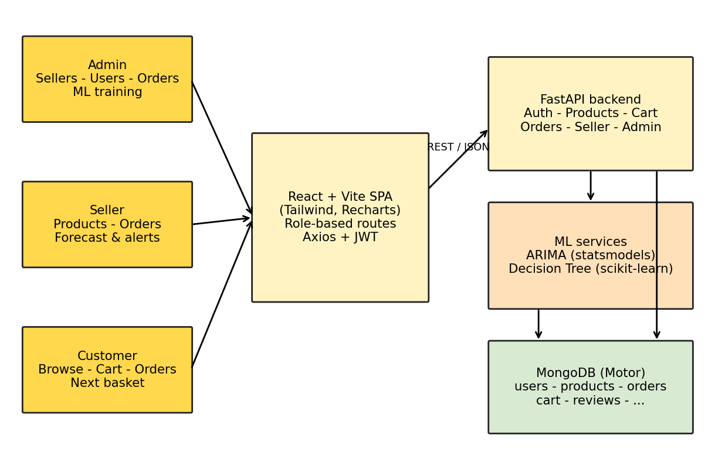
Figure 1: System Architecture
Table 2: Roles and capabilities
Role | Capabilities
Admin | Log in with configured credentials, approve or reject sellers, activate or deactivate users, view and delete products, view all orders, manage categories, train the models and watch their progress
Seller | Register (needs approval), add, edit and delete products, process orders, view analytics, run ARIMA stock forecasts and see shortage alerts
Customer | Register, search and browse products, add to cart, check out, view order history, write reviews, see next-basket recommendations

5.2. DATA FLOW DIAGRAM

5.2.1. LEVEL 0
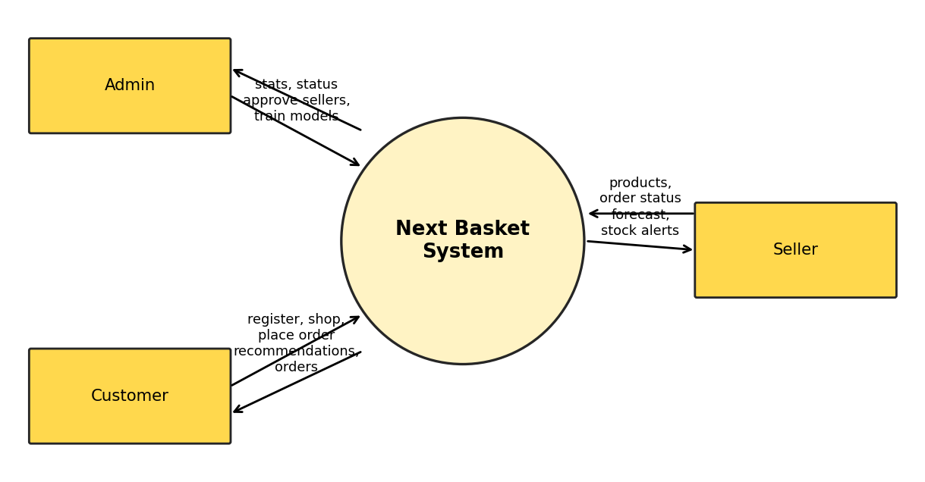
Figure 2: Level 0 Data Flow Diagram

5.2.2. LEVEL 1
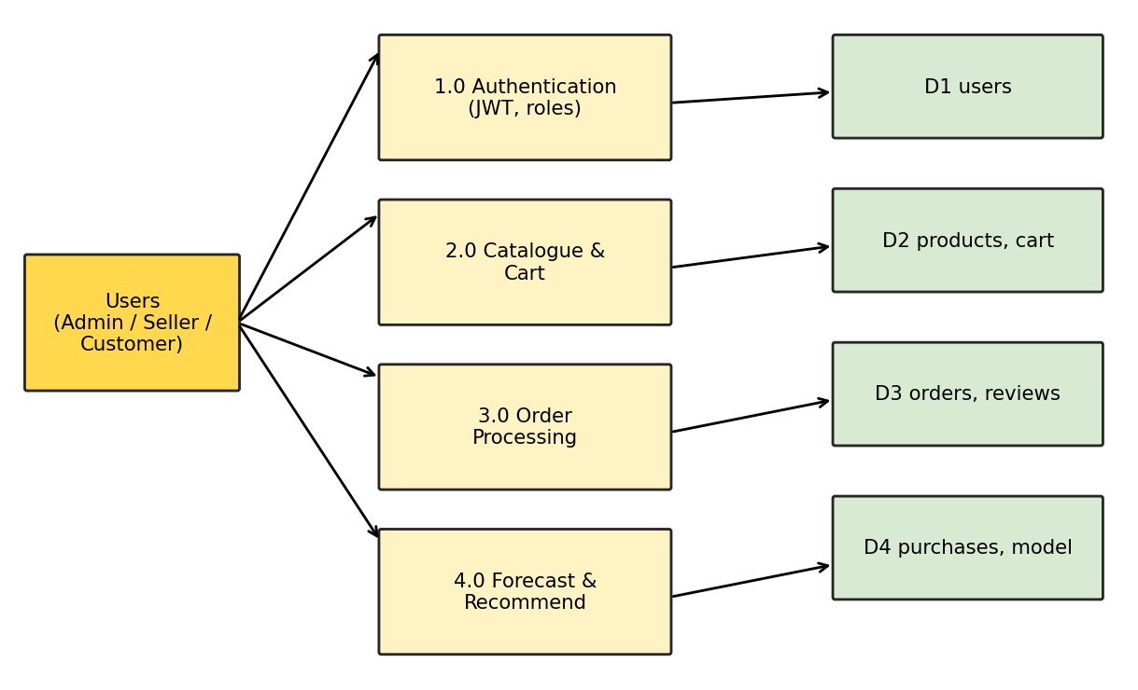
Figure 3: Level 1 Data Flow Diagram

5.2.3. LEVEL 2
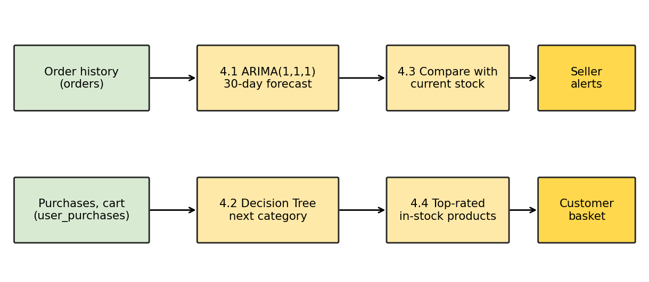
Figure 4: Level 2 Data Flow Diagram (Forecast and Recommend)

6. METHODOLOGY

6.1. SYSTEM DESCRIPTION
The platform follows a client-server design. On the front end, React components provide navigation menus, product listings, the shopping cart, order tables and the dashboards. On the back end, FastAPI routers (auth, products, cart, orders, seller, customer and admin) hold the business logic, validate requests with Pydantic models and enforce roles with a dependency that decodes the JWT. MongoDB stores users, products, categories, carts, orders, reviews, per-category purchase counts and search keywords.
Two machine-learning modules sit in the back end. The Forecaster Model collects daily order quantities for a product, checks stationarity, fits an ARIMA model and forecasts the next 30 days. The Recommendation Engine builds a feature vector from a customer's category purchase history and cart contents and uses a Decision Tree to predict the next category. Both are described in section 6.2.

System flow
- 1. A user opens the application and registers or logs in (sellers wait for admin approval).
- 2. Customers browse or search products; searched keywords are tracked.
- 3. Customers add products to the cart; quantities are limited to available stock.
- 4. At checkout the order is stored, stock is reduced and the cart is cleared.
- 5. Purchase counts per category are updated for the recommendation features.
- 6. Sellers see new orders and update their status (confirmed, shipped, delivered, cancelled).
- 7. Sellers open the forecast page; the ARIMA model forecasts 30-day demand and flags shortages.
- 8. The cart page shows the next-basket recommendations from the Decision Tree.
- 9. The administrator retrains the Decision Tree whenever enough new orders exist and follows the staged progress.

6.2. MODULES DESCRIPTION

6.2.1. E-Commerce Web App
The web app comprises the product, cart, order, review and user-management modules. Passwords are hashed with bcrypt, access tokens are signed JWTs valid for 24 hours, and every protected route declares the roles that may use it. The user interface uses a black trapezoid navigation bar, a yellow hero area on the landing, login and registration pages, white form cards with the label on the left, yellow-header tables and black-header cart tables. Prices are shown in rupees as "Rs. 5000.0".

6.2.2. Forecaster Model
Data collection: order lines are aggregated into daily quantities per product with a MongoDB pipeline. Pre-processing: missing days are filled with zero and the series is tested with the Augmented Dickey-Fuller test; it is differenced until stationary. Build and train: an ARIMA(1,1,1) model is fitted; if it fails to converge the fallback orders (1,1,0), (0,1,1), (1,0,0) and (0,1,0) are tried. Products with fewer than ten order days use a naive mean forecast. Performance: the model reports its AIC, and the Training page plots the fitted curve against actual demand.

6.2.3. Recommendation Engine (Decision Tree): Build and Train
Training data are built from every non-cancelled order line: the label is the category of the purchased item and the features are the customer's normalised category frequencies (with that purchase removed) and the cart-presence flags. The classifier uses max_depth 8, min_samples_split 3 and balanced class weights, is evaluated on a held-out split (stratified when every class has at least two samples) and is saved with joblib/pickle together with its label encoder.

6.2.4. Sales Forecasting
For a selected product the seller sees current stock, 30-day forecast demand, whether a shortage is predicted and the units needed, together with a chart of the forecast. The stock alerts page lists all of the seller's products with a predicted shortage.

6.2.5. Next Basket Recommendation
The model returns the top three most probable categories for the customer. For each category the top-rated in-stock products are returned and each carries a short recommendation reason. The cart page lists up to six recommended products beside the cart total. When no model exists, popular products are returned.

6.2.6. Actors Dashboard

Admin
- Platform statistics (users, sellers, products, orders, revenue)
- Approve or reject sellers; activate or deactivate users
- View and delete products, view all orders, manage categories
- Training page: train the Decision Tree and run the ARIMA pipeline with live progress

Customer
- Register, log in and update the profile
- Search and browse products, view details and reviews
- Cart with quantity check, checkout, order history
- Next-basket recommendations

Seller
- Register and wait for approval
- Add, edit and delete products and stock
- Process orders and view transaction history
- ARIMA stock forecast, shortage alerts, sales analytics, reviews

6.2.7. Training progress and notifications
Both training jobs run on the server and stream their stages to the browser as Server-Sent Events. The Training page shows a labelled progress bar and a step list in which each step is pending, active or done. For the Decision Tree the steps are: fetch categories, load the product catalogue, load order history, build purchase history, build training samples and train the tree; the result panel then shows accuracy, samples, classes and features. For ARIMA the steps are collect data, make stationary, build and train, and forecast, and the chart changes with the stage: the weekly demand history, then the raw and differenced series, then actual versus fitted demand, and finally the forecast with a 95% band.
Notifications are currently in-app: shortage alerts appear on the seller dashboard and order status is visible to customers and sellers. SMS and e-mail delivery (SMS gateway, SMTP) are not part of this version and are listed under future enhancements.

6.3. SYSTEM IMPLEMENTATION
- Environment setup: Python virtual environment, Node.js 18+, MongoDB on localhost:27017; start-dev.ps1 launches both servers.
- Database design: MongoDB collections with indexes created at start-up; the Sample Superstore dataset is seeded on first launch.
- Front-end development: React pages per role, shared components (navigation bar, footer, product card, protected route) and context providers.
- Back-end development: FastAPI routers with Pydantic validation, JWT authentication and role dependencies.
- Machine-learning integration: arima_service.py and recommendation_service.py are called by the seller, customer and admin routes.
- Testing: Manual functional testing of all roles (section 6.5); backend test scripts exercise the training stream.
- Deployment: Uvicorn for the API and a Vite production build for the front end; configuration is held in backend/.env.

6.4. SYSTEM TESTING
- Unit testing: Individual functions such as the feature-vector builder and the ARIMA fallback logic.
- Integration testing: Front end, API and MongoDB working together, including cart-to-order stock updates.
- Functional testing: Authentication, product browsing, cart, checkout, order management and forecasting for each role.
- User-interface testing: Navigation, form validation and layout at desktop widths.
- Security testing: Role checks on every protected route, token expiry and password hashing.
- Regression testing: Re-running the functional cases after each change.

6.5. TEST CASES
Table 3: Functional test cases
ID | Input / action | Expected result | Status
TC001 | Admin logs in with valid credentials | Admin dashboard opens | To be executed
TC002 | Admin approves a pending seller | Seller can then log in | To be executed
TC003 | Admin opens the Training page and starts training | Progress bar and steps advance to 100% | To be executed
TC004 | Admin deactivates a user | User can no longer log in | To be executed
TC005 | Customer registers | Account created | To be executed
TC006 | Customer logs in | Product page opens | To be executed
TC007 | Customer searches by keyword or category | Matching products listed | To be executed
TC008 | Customer adds a product to the cart | Item appears in the cart | To be executed
TC009 | Customer opens the cart | Next-basket recommendations are listed | To be executed
TC010 | Customer presses Buy Now | Order stored, stock reduced, cart cleared | To be executed
TC011 | Seller registers | Account created, awaiting approval | To be executed
TC012 | Approved seller logs in | Seller dashboard opens | To be executed
TC013 | Seller edits product details | Changes saved | To be executed
TC014 | Seller adds, edits and deletes products and stock | Inventory updated | To be executed
TC015 | Seller views customer reviews | Reviews and ratings shown | To be executed
TC016 | Seller updates an order status | Customer sees the new status | To be executed
TC017 | Seller opens the stock forecast for a product | 30-day forecast chart and shortage flag shown | To be executed
TC018 | Seller opens alerts | Products with predicted shortage listed | To be executed
TC019 | Seller checks stock levels | Current quantities shown | To be executed
TC020 | Seller opens analytics | Monthly, category and top-product figures shown | To be executed
TC021 | Seller views reviews for own products | Ratings shown | To be executed
TC022 | Seller views order history | Orders containing own products listed | To be executed

6.6. TEST REPORT
The 22 test cases above define the functional acceptance test for this version of the platform. They were carried over from the earlier version of the project and re-written for the React, FastAPI and MongoDB implementation. Their execution status is recorded in the Status column; entries marked "To be executed" have not yet been run against this build and no pass rate is claimed for it. Items checked during development: the ARIMA training pipeline streams all four stages, the staged progress and charts render correctly on the Training page, and the front end builds without errors.

7. RESULTS

7.1. SCREENSHOTS
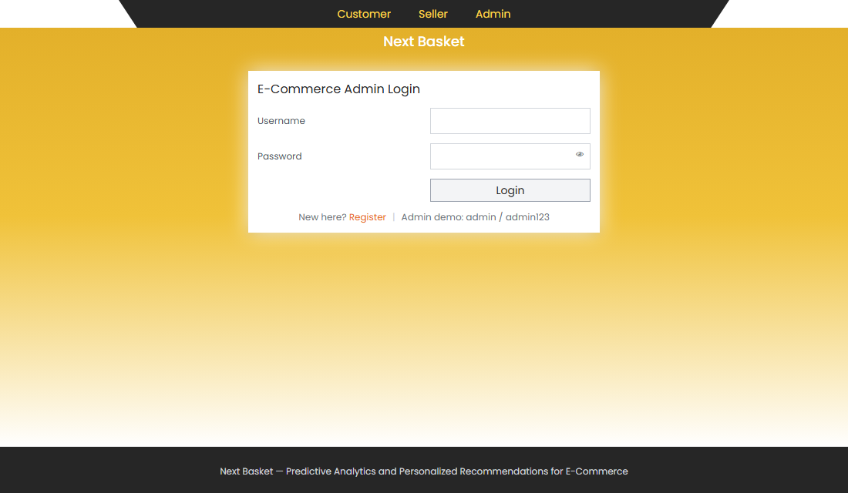
Figure 5: Admin Login
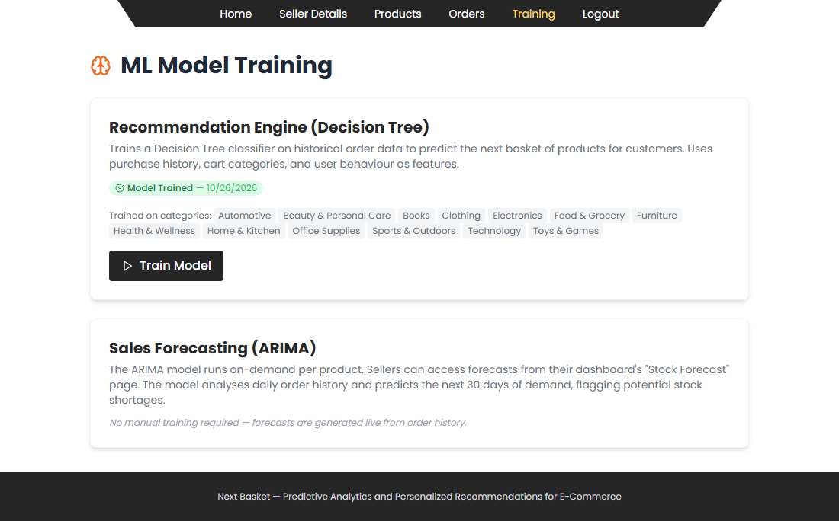
Figure 6: Training Phase
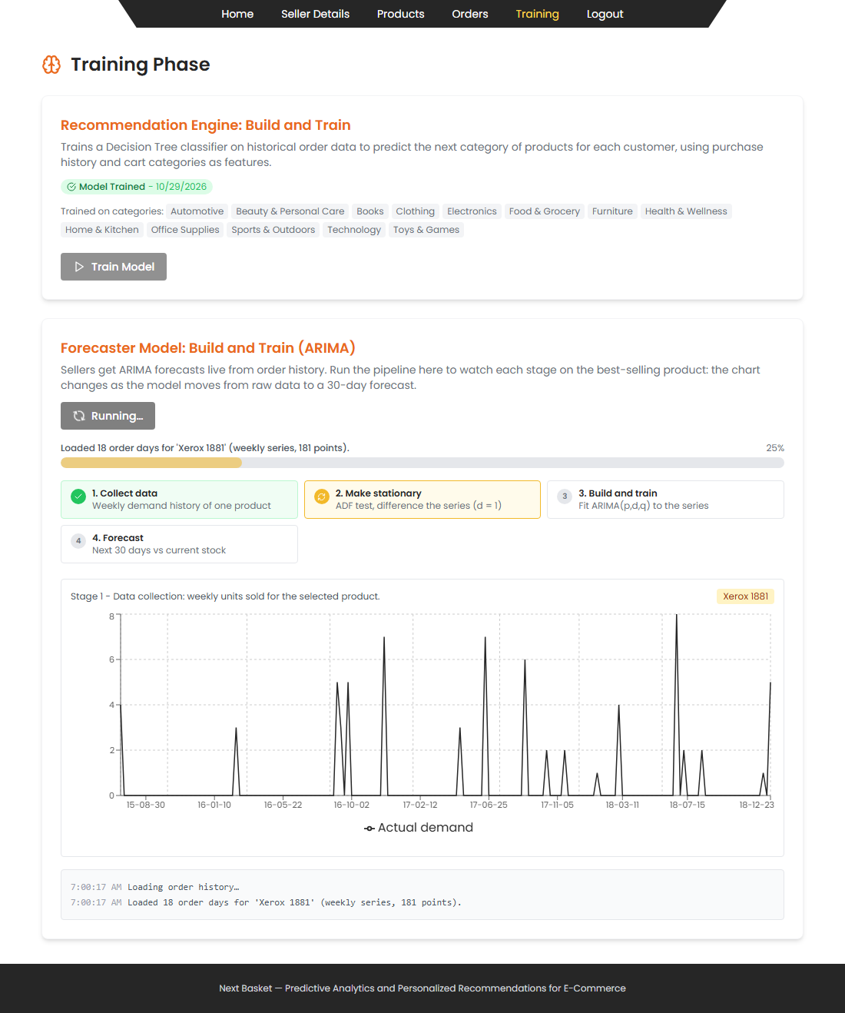
Figure 7: Forecaster Model: Data Collection (ARIMA stage 1)
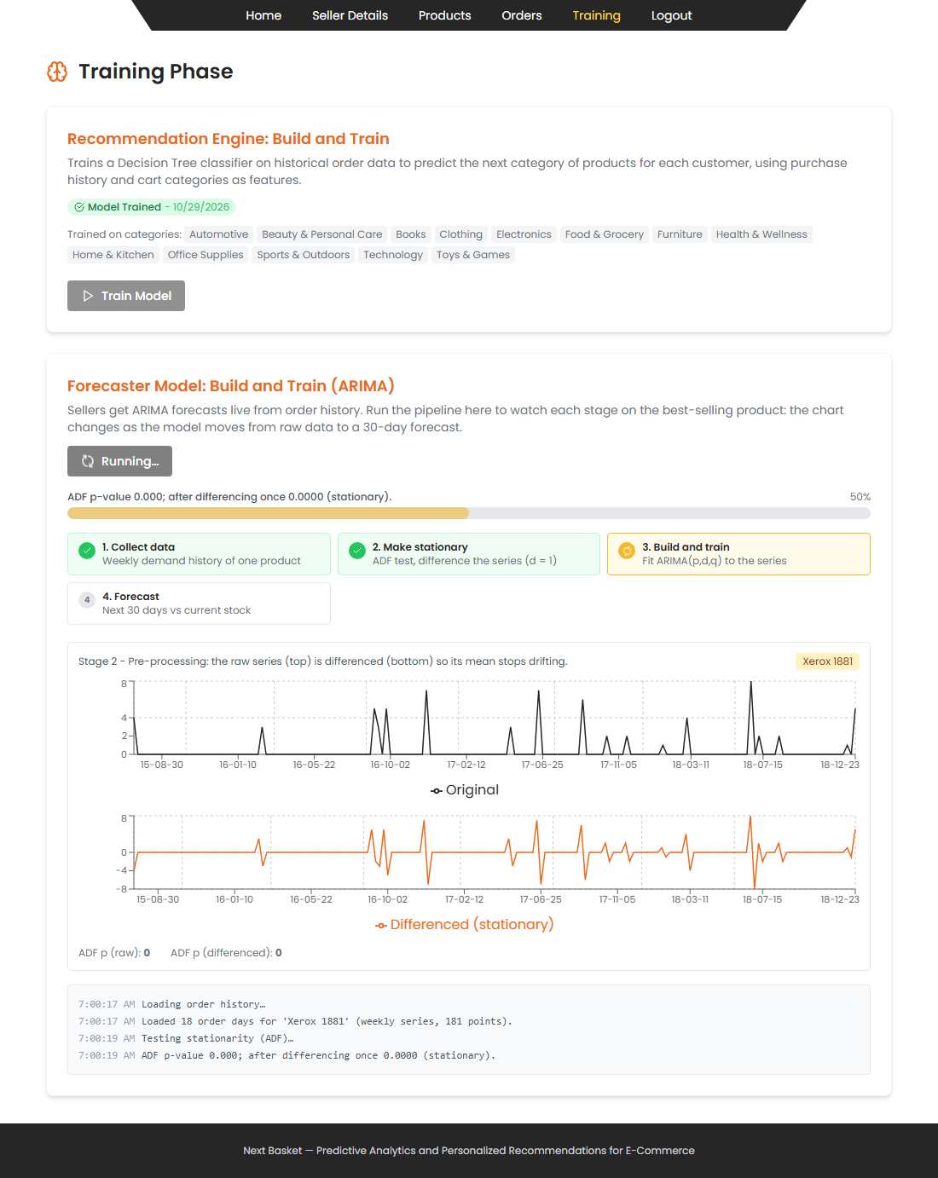
Figure 8: Forecaster Model: Pre-processing (ARIMA stage 2)
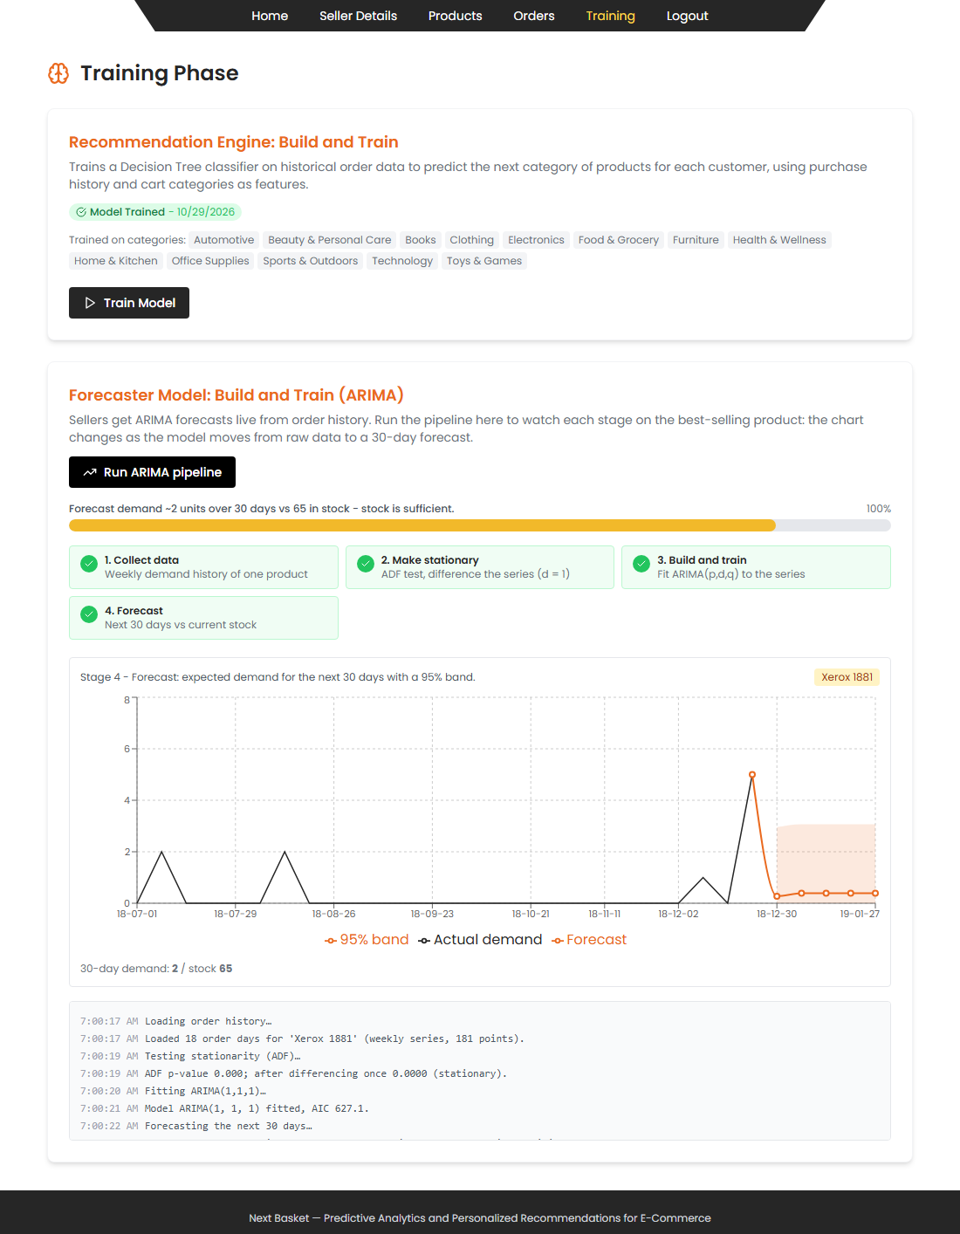
Figure 9: Forecaster Model: Build and Train (ARIMA stage 3)
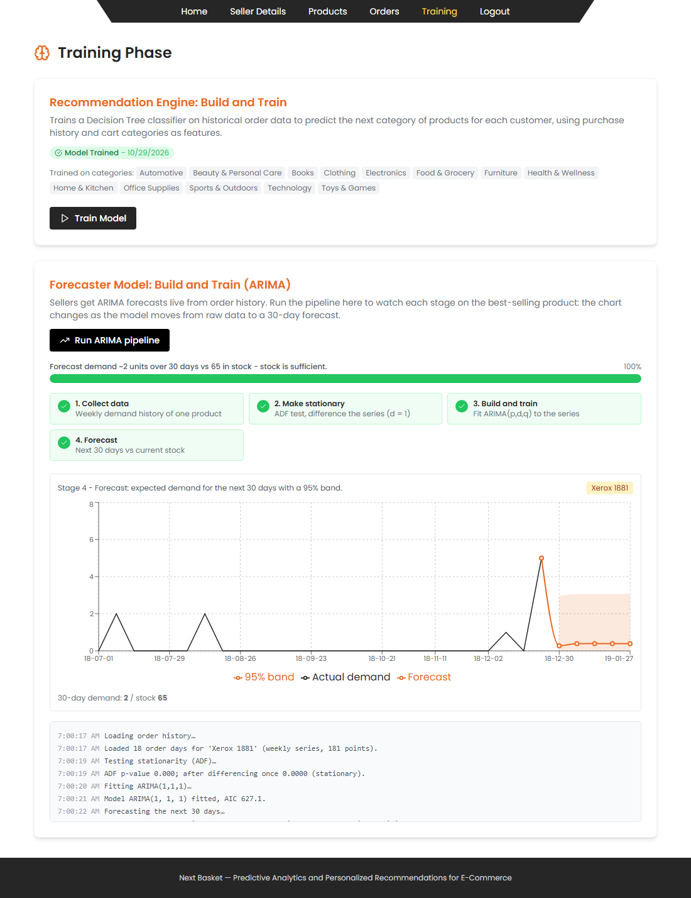
Figure 10: Forecaster Model: Forecast (ARIMA stage 4)
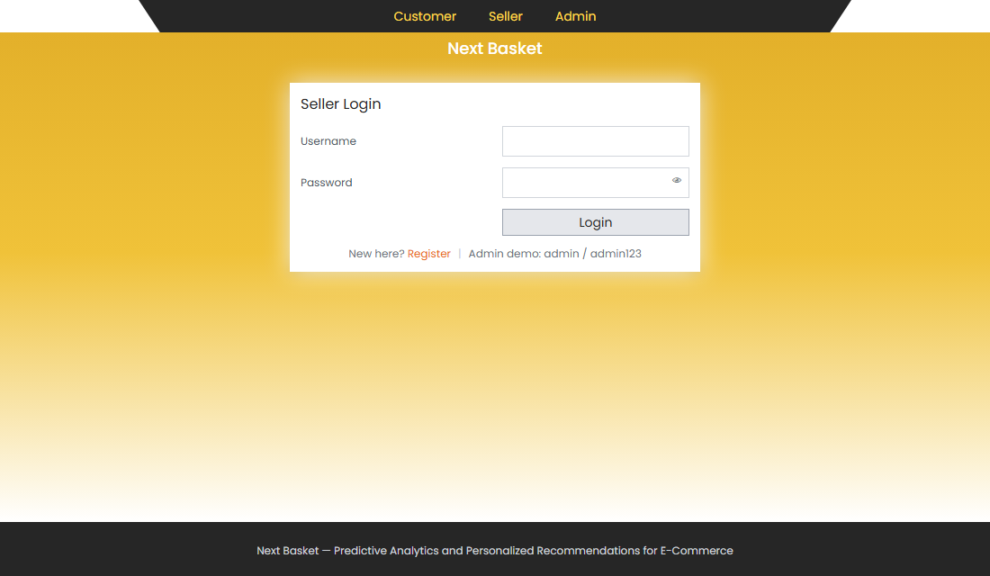
Figure 11: Seller Login
Figure 12: Add Product
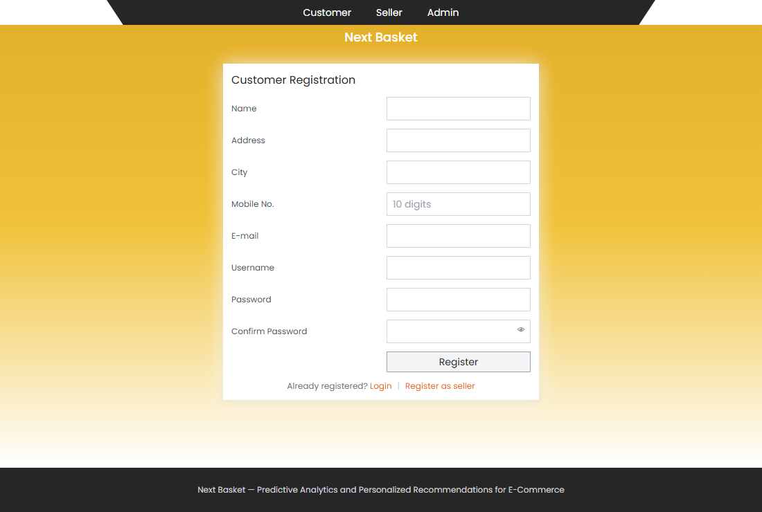
Figure 13: Customer Registration
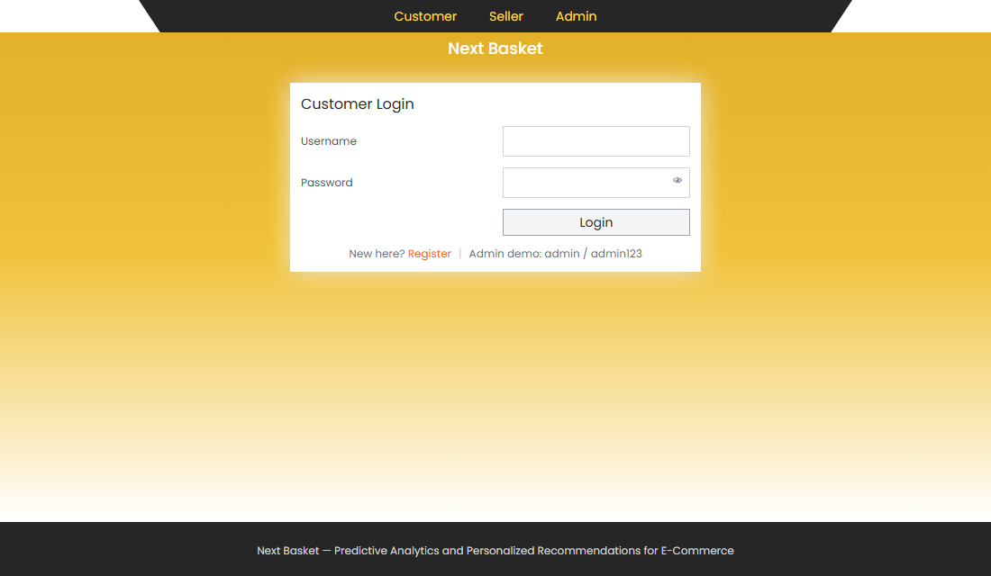
Figure 14: Customer Login
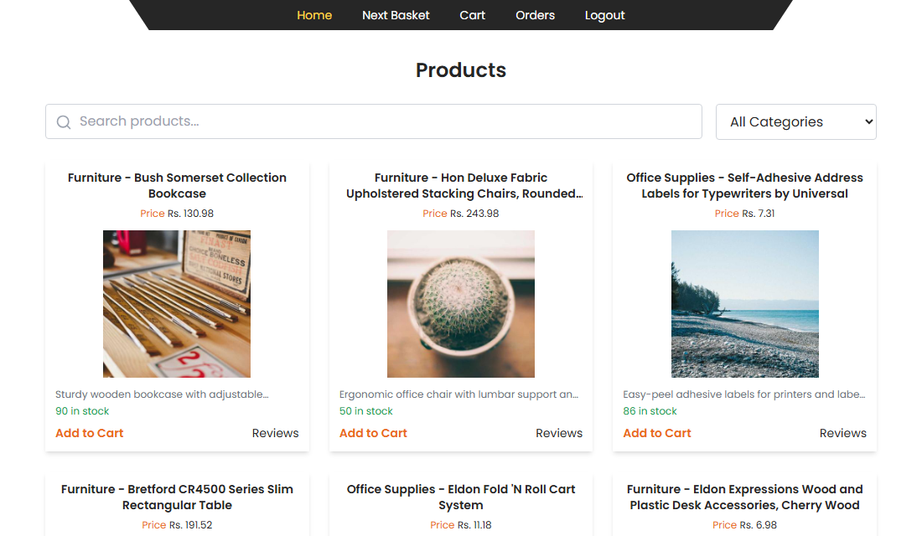
Figure 15: Products
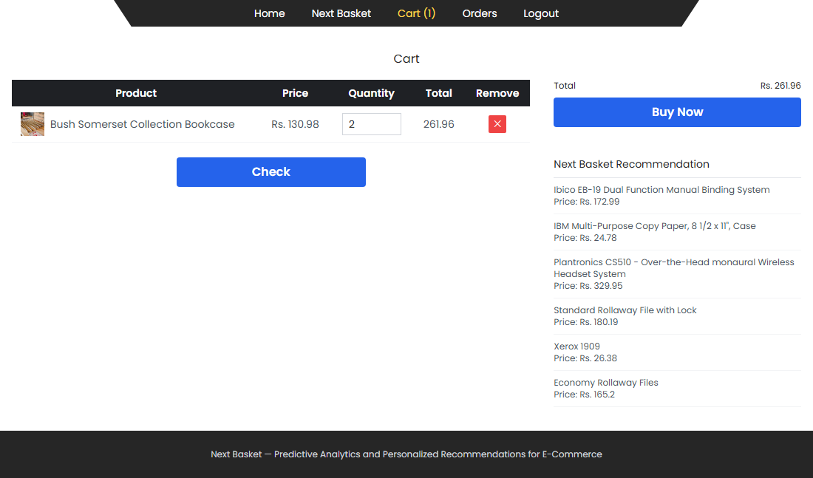
Figure 16: Cart and Next Basket Recommendation
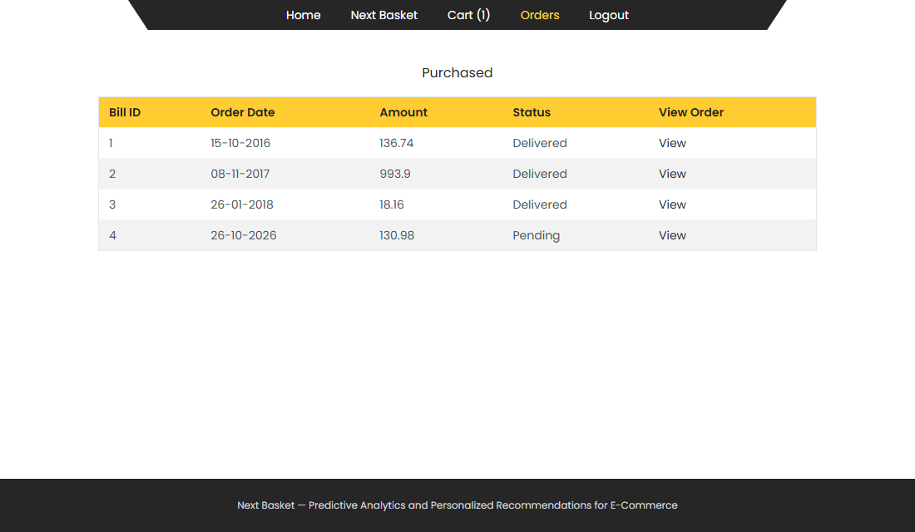
Figure 17: Purchased Orders
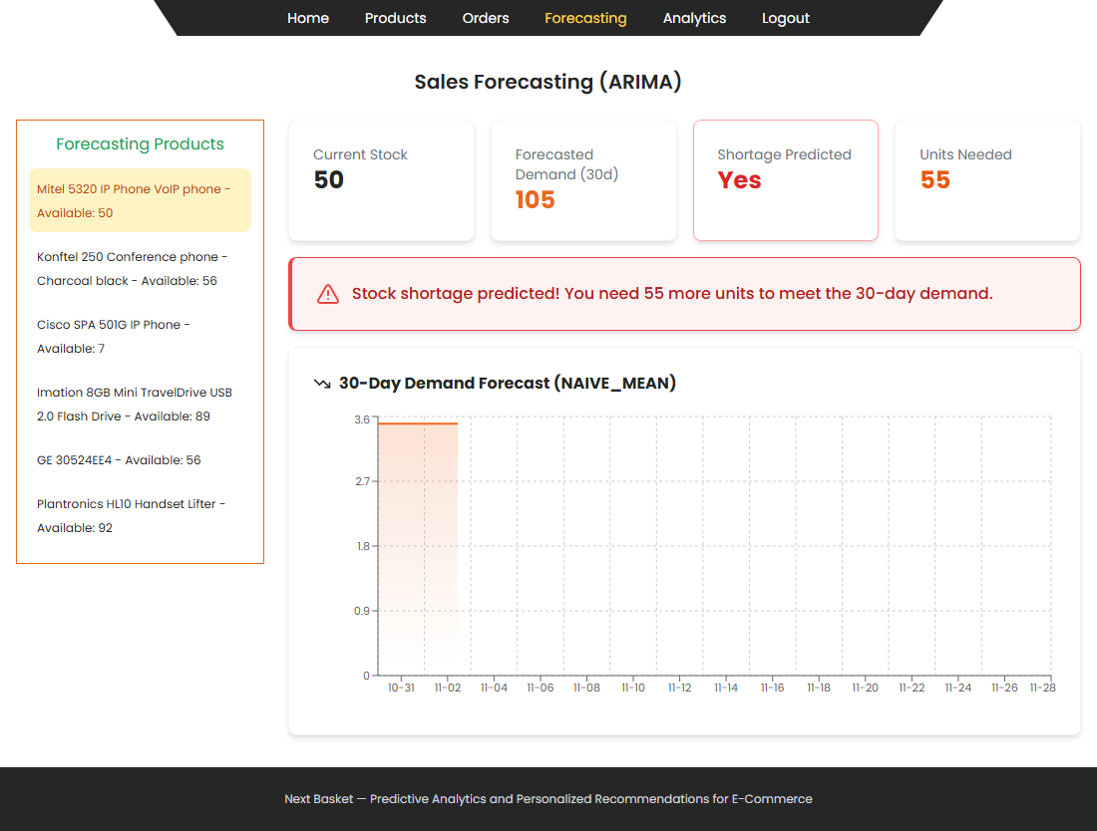
Figure 18: Sales Forecasting

7.2. PACKAGES
Key imports and settings of the implementation are listed below.
# backend/requirements.txt (extract)
fastapi==0.111.0 uvicorn[standard]==0.30.1
motor==3.4.0 pymongo==4.7.3
python-jose[cryptography]==3.3.0 bcrypt==4.1.3
pandas==2.2.2 numpy==1.26.4
scikit-learn==1.5.0 statsmodels==0.14.2
matplotlib==3.9.0 seaborn==0.13.2 joblib==1.4.2

Database connection
async def connect_db():
global client, db
client = AsyncIOMotorClient(settings.mongo_url)
db = client[settings.db_name]
# Create indexes
await db.users.create_index("username", unique=True)
await db.users.create_index("email", unique=True)
await db.products.create_index("seller_username")
await db.products.create_index("category")
await db.orders.create_index("customer_username")
await db.orders.create_index("seller_username")
await db.cart.create_index("customer_username")
await db.user_searches.create_index("customer_username")
await db.reviews.create_index("product_id")
print("✅ Connected to MongoDB")

Registration and login (auth.py)
user_doc = {
"username": user_in.username,
"name": user_in.name,
"email": user_in.email,
"password": hash_password(user_in.password),
"mobile": user_in.mobile,
"location": user_in.location,
"role": user_in.role,
"is_active": True,
# seller-specific
"address": user_in.address,
"city": user_in.city,
# sellers need admin approval
"is_approved": user_in.role == "customer",
"approval_status": "approved" if user_in.role == "customer" else "pending",
"created_at": datetime.utcnow(),
}

await db.users.insert_one(user_doc)

Add to cart (cart.py)
await db.cart.insert_one({
"customer_username": current_user["username"],
"product_id": body.product_id,
"quantity": body.quantity,
"added_at": datetime.utcnow(),
})

ARIMA model fitting (arima_service.py)
def fit_arima(series: pd.Series, order: Tuple[int, int, int] = (1, 1, 1)) -> ARIMA:
"""Fit an ARIMA model to the series with fallback orders."""
fallback_orders = [order, (1, 1, 0), (0, 1, 1), (1, 0, 0), (0, 1, 0)]
for o in fallback_orders:
try:
model = ARIMA(series.values, order=o)
fit = model.fit()
return fit
except Exception as e:
logger.warning(f"ARIMA{o} failed: {e}")
raise ValueError("Could not fit any ARIMA model to the series.")

Decision Tree training (recommendation_service.py)
clf = DecisionTreeClassifier(
max_depth=8,
min_samples_split=3,
min_samples_leaf=1,
class_weight="balanced",
random_state=42,
)
clf.fit(X_train, y_train)
accuracy = float(accuracy_score(y_test, clf.predict(X_test)))

Next-category prediction (recommendation_service.py)
feat = _build_feature_vector(category_list, user_history, cart_categories)
proba = clf.predict_proba([feat])[0]

top_indices = np.argsort(proba)[::-1][:top_n]
top_categories = [le.classes_[i] for i in top_indices if proba[i] > 0.01]
return top_categories

7.2.1. REST API summary
Table 4: API endpoints
Group | Endpoints
Auth | POST /api/auth/register, POST /api/auth/login
Products | GET /api/products, GET/PUT/DELETE /api/products/{id}, POST /api/products, GET/POST /api/products/{id}/reviews, GET /api/products/categories
Cart | GET /api/cart, POST /api/cart/add, PUT/DELETE /api/cart/{id}, DELETE /api/cart
Orders | POST /api/orders, GET /api/orders/my, GET /api/orders/seller, PATCH /api/orders/{id}/status
Seller | GET /api/seller/stats, /analytics/sales, /forecast/{id}, /alerts, /products, /profile
Customer | GET /api/customer/recommendations, GET/PUT /api/customer/profile, POST /api/customer/search-track
Admin | GET /api/admin/stats, /sellers, /customers, /products, /orders; PATCH /sellers/approve; POST /api/admin/ml/train (SSE); POST /api/admin/ml/arima (SSE); GET /api/admin/ml/status

7.3. DATABASE DESIGN
Data are stored in MongoDB collections. Each document also has an automatically generated _id. Types are those of the stored values.
Table 5: Structure of the users collection (admin, sellers, customers)
S.no | Field | Type | Description
1 | username | string, unique | Login name
2 | email | string, unique | E-mail address
3 | name | string | Full name
4 | password | string | bcrypt hash
5 | mobile | string | 10-digit mobile number
6 | location | string | Customer location
7 | role | string | customer or seller
8 | is_active | bool | Account enabled
9 | address, city | string | Seller address
10 | is_approved | bool | Seller approved by admin
11 | created_at | datetime | Registration date

Table 6: Structure of the categories collection
S.no | Field | Type | Description
1 | name | string | Category name
2 | created_at | datetime | Created on

Table 7: Structure of the products collection
S.no | Field | Type | Description
1 | name | string | Product name
2 | category | string | Category name (indexed)
3 | price | float | Unit price
4 | quantity | int | Stock on hand
5 | description | string | Short description
6 | image_url | string | Product photo URL
7 | seller_username | string | Owner (indexed)
8 | created_at | datetime | Created on

Table 8: Structure of the cart collection
S.no | Field | Type | Description
1 | customer_username | string | Owner (indexed)
2 | product_id | string | Product reference
3 | quantity | int | Units in cart
4 | added_at | datetime | Added on

Table 9: Structure of the orders collection
S.no | Field | Type | Description
1 | customer_username | string | Buyer (indexed)
2 | items | array | product_id, product_name, quantity, price, seller_username
3 | total_amount | float | Order total
4 | status | string | pending, confirmed, shipped, delivered, cancelled
5 | created_at | datetime | Order date
6 | updated_at | datetime | Last status change

Table 10: Structure of the reviews collection
S.no | Field | Type | Description
1 | product_id | string | Product (indexed)
2 | customer_username | string | Reviewer
3 | rating | int | 1 to 5 stars
4 | comment | string | Review text
5 | created_at | datetime | Review date

Table 11: Structure of the user_purchases collection (recommendation features)
S.no | Field | Type | Description
1 | customer_username | string | Customer
2 | category | string | Category
3 | count | int | Units purchased

Table 12: Structure of the user_searches collection
S.no | Field | Type | Description
1 | customer_username | string | Customer (indexed)
2 | keyword | string | Search keyword (lower case)
3 | count | int | Times searched

8. CONCLUSION
Next Basket integrates ARIMA sales forecasting and a Decision Tree recommendation engine into a three-role e-commerce platform built with React, FastAPI and MongoDB. The forecaster lets sellers see likely demand for the next 30 days and know in advance when stock will fall short, while the recommendation engine suggests the next basket of products to customers from their purchase history and cart. The administrator can retrain the models and follow every stage of the process, with a labelled progress bar, a step list and, for ARIMA, a chart that changes with each stage.
Limitations of the current version are that notifications are in-app only, that payment is not processed (an order is recorded when the customer presses Buy Now), that the recommendation model works at category level, and that the functional test cases still have to be executed and recorded against this build.

Future Enhancement
Planned enhancements are SMS and e-mail notifications, an online payment gateway, product-level recommendations, personalized marketing campaigns based on customer segmentation, and dynamic pricing driven by demand forecasts.

REFERENCES
BOOK REFERENCES
1. Online Retailing: Concepts, Strategies, and Applications by Nikhilesh Dholakia, et al.
2. Predictive Analytics: The Power to Predict Who Will Click, Buy, Lie, or Die by Eric Siegel
3. Machine Learning for Dummies by John Paul Mueller and Luca Massaron
4. E-Commerce 2019: Business, Technology, and Society by Kenneth C. Laudon and Carol Guercio Traver
5. Practical Predictive Analytics by Ralph Winters
6. Building Machine Learning Powered Applications by Emmanuel Ameisen
7. "Python Crash Course" by Eric Matthes
8. "Introduction to Machine Learning with Python" by Andreas C. Muller and Sarah Guido
WEB REFERENCES
1. FastAPI documentation - https://fastapi.tiangolo.com/
2. MongoDB documentation - https://www.mongodb.com/docs/
3. React documentation - https://react.dev/
4. Scikit-learn documentation - https://scikit-learn.org/stable/documentation.html
5. statsmodels ARIMA - https://www.statsmodels.org/stable/generated/statsmodels.tsa.arima.model.ARIMA.html
6. Sample Superstore dataset - https://www.kaggle.com/datasets/bravehart101/sample-superstore-dataset
7. KDnuggets - https://www.kdnuggets.com/
8. Towards Data Science - https://towardsdatascience.com/

